Enigma
Project 1

The enigma machine was an enciphering machine used by Germany during the Second World War. Though the code was finally broken, the enigma proved to be one of the most complex enciphering devices known. The enigma used a system of rotors and plugs to change a message the operator typed in to an encipher message. In order to decipher a coded message, a user needed an Enigma machine and the correct rotor and plug settings. In this project, you will need to simulate the rotor system of the enigma machine. The rotors were disks that took an input letter and changed it to a specific output. There were four moveable rotors (though they won’t move in this project) and one set rotor (called the reflector). A signal (an input letter) would pass through the four rotors, then through the reflector, which would reflect the signal back through the four rotors.
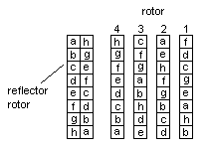
illustration
You will need to create four normal rotors and a reflector rotor. The rotors, given one letter, will generate another letter based on a set pattern. Each rotor consists of the entire alphabet in random order. The reflector rotor is two, parallel lists of letters that match symmetrically (e.g. “a” becomes “h” and “h” becomes “a”). The input signal travels through the banks of four rotors, then reflects off the reflector and back through the rotors to its final output.

Example:
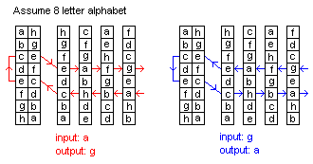

Requirements:
Create a project that simulates the enigma rotor system. You must be able to encode or decode entire messages.

Example Program Input/Output:

Input: RETREAT Input: UGWUGQW
Output: UGWUGQW Output: RETREAT

Extension:
Now you must modify the rotors of the enigma machine. The four normal rotors (not the reflector) must be able to be rotated. For example on setting 0 for rotor 1, an input of “a” might become an output of “g,” but for setting 1 for rotor 1, an input of “a” might become an output of “f.” Each rotor must have twenty-six settings (0-25), one rotation for each letter of the alphabet.

